Equipment rental charges apply

 | equipment | Refer to the photo | detail | One day rent  (each). | Deposit  (each).
1 | Towed amplifier | 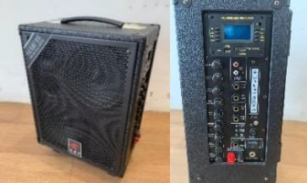 | OMS-618  Connects 2 handheld wireless microphones  295 x 180 x 385mm (L x W x H). | $200 | $500
2 | Built-in ceiling projector | 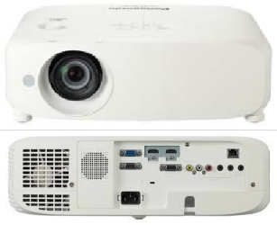 | Panasonic PT-VZ580  Resolution: 1920 x 1200, 16:10,  5000 Lumen  389 x 332 x 125mm (L x W x H). | $400 | $2,000
3 | Portable projector | 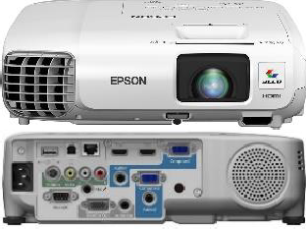 | Epson EB-945H  Resolution: 1024 x 768, 4:3, 3000  Lumen  297 x 244 x 87mm (L x W x H). | $200 | $2,000
4 | TV stands | 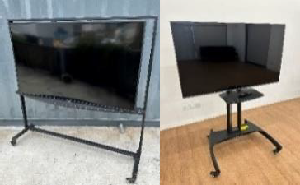 | SAMSUNG UA65NU7100 (left) 1610 x 400 x 1630mm  or  LG 55UQ9100PCD (right) 1235 x 720 x 1550mm  (L x W x H).  Applicable to 02 & 03 venues only | $300 | $2,000

5 | Stacking stools | 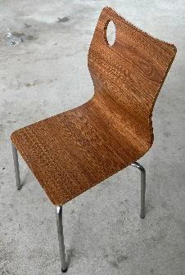 | *Quantity available for rent  01: 40 Sheets  02: 25 Sheets  03: 40 Sheets | $20 | $20  Margin Limit:  $500
6 | Folding stool | 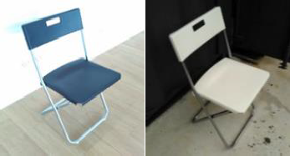 | *Quantity available for rent  (White) 01: 40 sheets  (Black) 03: 40 sheets | $15 | $20  Margin Limit:  $500
7 | Round stool | 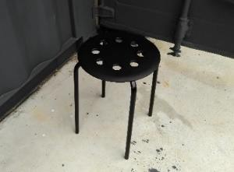 | *Quantity available for rent  01:40 Sheets  02:40 Sheets  03:40 sheets | $10 | $15  Margin Limit:  $500
8 | Pull the strap | 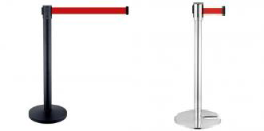 | The longest length of the pull strap is about 1900mm  Number available to rent: 20  Styles are subject to availability, and only one style will be available for the same event | $20 | $150
9 | Poster stands | 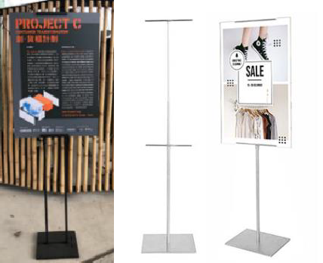 | The height of the poster is 120-1500mm  The thickness of the poster should not exceed 6mm (the height of the A1 poster is about 840mm).  Number available to rent: 10  Styles are subject to availability, and only one style will be available for the same event | $20 | $200

10 | blow dryer | 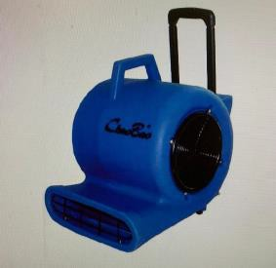 | Power: 900W  Air flow: 160 / 130 / 110m3 per minute  Number available to rent: 6 | $50 | $200
11 | whiteboard | 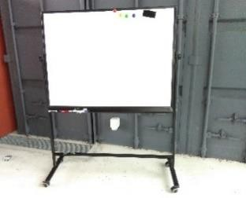 | Frame: 1260 x 510 x 1665mm (L x W x H).  Whiteboard: 1200 x 900mm (L x W).  Number of available for rent: 1 | $50 | $500
12 | Floor type induction cooker with oven | 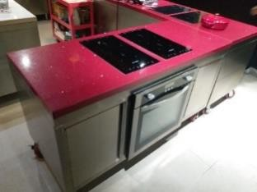 | Number available to rent: 3  03 only | $500 | $1,000
* If the quantity of equipment you rent exceeds the amount available at the venue (e.g. more than 18 folding tables at 03), we will do so
Passengers will be relocated from other venues on the Discovery and will be charged a flat shipping fee of HK$2,200. This fee will only be charged once per application.

